34.24: a) 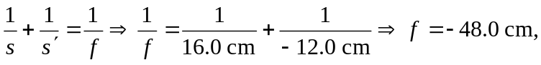and the lens is diverging.
b) 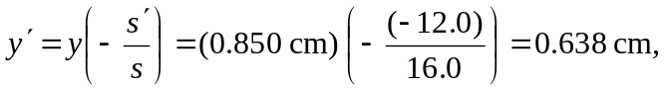and is erect.
c)

